**BENEFITS OF PURE ESSENTIAL OIL IN BATH & WELLNESS Products**

Bogue Milk Soap has been crafting products that are all-natural and effective since 1973 in Ojai, CA. Our soap starts with a base of more than twelve organic plant-based oils & butters before the essential oils are added after they are meticulously researched for their therapeutic properties. Essential oils are the concentrated liquids derived from different parts of plants leaves, roots, seeds, they are the essence of the plant from which they are derived. [Goat Milk](https://www.healthline.com/nutrition/goat-milk-soap-benefits#_noHeaderPrefixedContent) has many benefits of its own so Goat Milk soap is a great way to get the aroma therapeutic as well as topical beneficial properties of Essential oils.

Used for centuries, essential oils are best extracted through pressing or the process of distillation, often by using steam. Bogue Milk Soap has Essential oil blend roll-ons with perfume grade amounts as well as hydrolyzing sprays, but everything starts with the essential oils used in our soaps. Some of the common essential oils we add to our goat milk soap & skincare products and the beneficial properties they offer are:

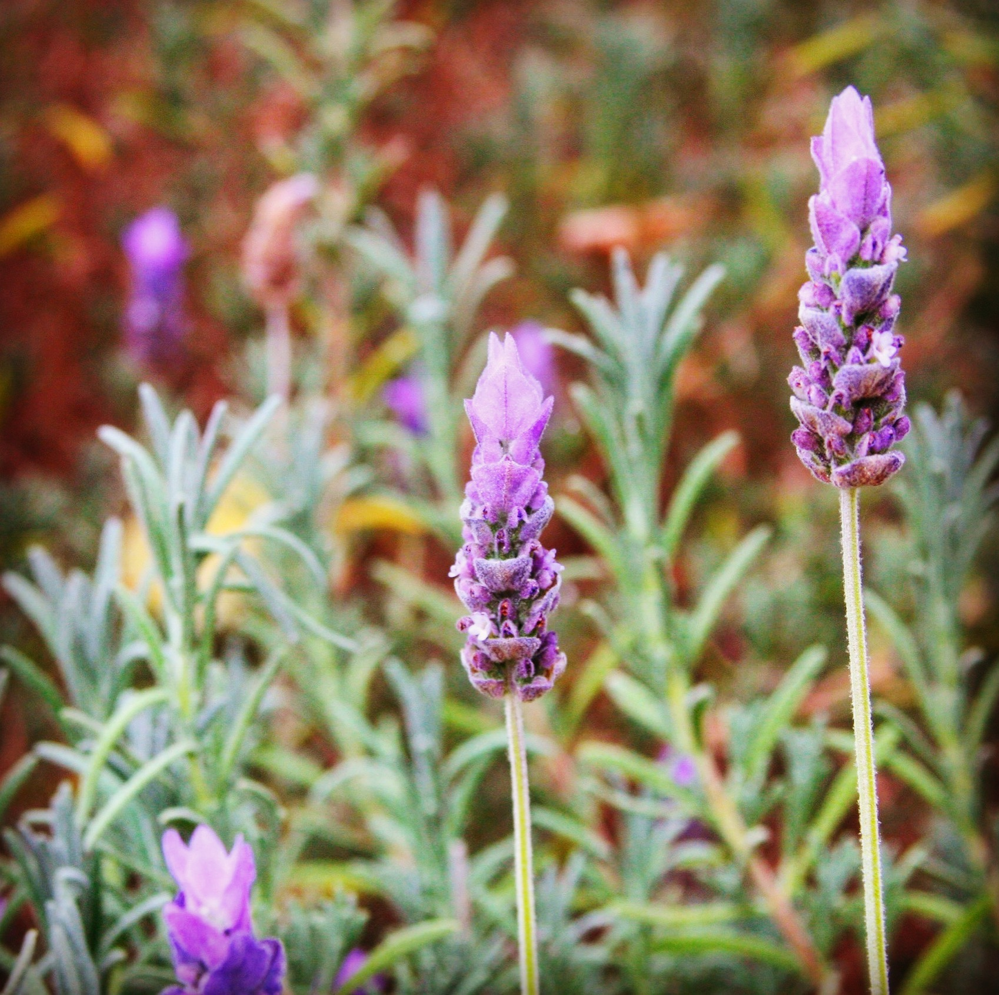

**Lavender**

We use Lavender probably more than any other EO, as it has been a staple of essential oil using community forever with its ability to soothe & calm. The relaxing scent of lavender can ease stress, anxiety and even reduce headaches.

Topically Lavender is beneficial for the skin. In a 2016 [study](https://www.ncbi.nlm.nih.gov/pubmed/27229681), lavender essential oil is a collagen booster and aids in healing skin tissues while it’s antibacterial properties make it helpful in fighting acne. Linalool and linalyl acetate, are present in lavender essential oil and have powerful antioxidant qualities. At BMS we love Lavender and grow it all around our Ojai property. You can enjoy it in:

[Essential oil Roll-on No.6 Walk in Ojai Blend](https://www.boguemilksoap.com/product/essential-oil-roll-on-with-lavender-sage/)

[Essential Oil Hydrolizer Spray No.9 Shangri-La Blend](https://www.boguemilksoap.com/product/pure-essential-oil-hydrolyzer-spray/)

[Essential oil Roll-On No.9 Shangri-La Blend](https://www.boguemilksoap.com/product/pure-essential-oil-roll-on-no-9-shangri-la-blend-of-local-flora/)

[Goat Milk Body Lotion No.9 Shangri-La Blend](https://www.boguemilksoap.com/product/n9-shangri-la-blend-goat-milk-hand-body-lotion/)

[Handmade Goat Milk Soap No.34 Calm Down Blend](https://www.boguemilksoap.com/product/n-34-wellness-calm-down/)

**Palo Santo**

One of the most popular scents lately Palo Santo the “holy wood” has been used by indigenous peoples for centuries. Traditionally as a natural remedy you can apply to your skin or burn as incense to reduce pain, inflammation, and stress.

[Share on Pinterest](https://www.pinterest.com/pin/create/button/?url=https%3A%2F%2Fwww.healthline.com%2Fhealth%2Fpalo-santo-benefits&media=https%3A%2F%2Fpost.healthline.com%2Fwp-content%2Fuploads%2F2020%2F06%2Fpalo_santo_wood-1296x728-header.jpg&description=Palo%20Santo%20Benefits%2C%20Uses%2C%20Precautions%2C%20and%20How%20to%20Use%20it)

Palo Santo (*Bursera graveolens*) is a tree that’s native to Peru, Ecuador, and other South American countries. It grows in dry tropical forests and produces very fragrant resin. For thousands of years, the wood, resin, and oil have been used for medicinal purposes. It’s mainly used to treat pain and stress. It’s also said to clear negative energy. Another supposed benefit is pain relief. People use palo santo to treat different types of pain, this effect may be related to limonene. A [2017 reviewTrusted Source](https://www.ncbi.nlm.nih.gov/pmc/articles/PMC5751100/) states the substance has analgesic (pain-relieving) and anti-inflammatory properties. Limonene can provide relief by inhibiting certain neuronal pathways, according to a [2016 studyTrusted Source](https://pubmed.ncbi.nlm.nih.gov/27030509/) on animals.

[Essential oil Roll-On No.20 Palo Santo](https://www.boguemilksoap.com/product/pure-essential-oil-roll-on-no-20-palo-santo-blend-aromatherapy/)

[Goat Milk Soap No.20 Palo Santo Blend](https://www.boguemilksoap.com/product/handmade-goat-milk-bar-soap-with-essential-oils-of-palo-santo/)

[Essential Oil Roll-On No.31 Rejuvenating Blend](https://www.boguemilksoap.com/product/pure-essential-oil-roll-on-bogue-wellness-no-31-rejuvenating-blend-uplifting-lemon-peppermint-healing-palo-santo/)

[Organic Shower Gel No.20 Palo Santo Blend](https://www.boguemilksoap.com/product/n-20-palo-santo-blend-shower-gel-valley-of-the-moon-hair-body-with-soothing-skin-firming-palo-santo-with-juniper-elemi-cedarwood-vetiver/)

[Organic Hair Conditioner No.20 Palo Santo Blend](https://www.boguemilksoap.com/product/bogue-milk-soap-conditioner/)

**Grapefruit**

When inhaled, grapefruit essential oil is a great stress reliever, known to lessen symptoms of depression, it’s a very uplifting scent. Topically applied to the skin, it provides a refreshing sensation and can be beneficial for treating stiffness and cramps in the muscles. In our goat milk soap, it is also good for treating oily skin and acne.

[Goat Milk Soap bar No.32 Detox Blend](https://www.boguemilksoap.com/product/wellness-detox-blend/)

[Goat Milk Shaving Soap Kit No.16 Topa Topa Blend](https://www.boguemilksoap.com/product/goat-milk-shaving-soap-kit-topa-topa-blend-with-13-essential-oils-rhassoul-clay/)

**Peppermint**

Peppermints minty scent when inhaled can have an uplifting while cooling & relaxing effect on the mind. While this can soothe headaches, it can provide pain relief when applied topically especially for sun kissed skin. Peppermint contains menthol which creates a cooling sensation when applied to the skin that often helps with muscle relaxation. Enjoy the wonders of Peppermint used in these products:

[Essential oil Roll-On No.18 Surf Rider Blend](https://www.boguemilksoap.com/product/pure-essential-oil-roll-on-no-18-surf-rider-blend-with-cooling-peppermint/)

[Goat Milk Soap No.18 Surf Rider Blend](https://www.boguemilksoap.com/product/no-18-surf-wash/)

[Goat Milk Shave Soap Kit No.17 Chiefs peak Blend](https://www.boguemilksoap.com/product/shave-kit-activated-charcoal-kaolin-clay/)

[Goat Milk Body Lotion No.31 Rejuvenating Blend](https://www.boguemilksoap.com/product/goat-milk-body-lotion-wellness-no-31-rejuvenating-blend/)

[Essential Oil Hydrolizing Spray No.31 Rejuvenating Blend](https://www.boguemilksoap.com/product/pure-essential-oil-hydrolizer-spray-wellness-no-31-rejuvenating-blend/)



**Rosemary**

Growing everywhere and used in cooking Rosemary is wonder for variety of common skin issues. It has antimicrobial and antiseptic properties that have been known to help soothe eczema, dermatitis, oily skin, and acne. BMS adds many beneficial oils to our organic shampoo, continued use of rosemary essential oil has been known to strengthen hair by stimulating the hair follicles. Rosemary essential oil is one of nature's best relaxers, because it decreases the [levels of cortisol](https://www.sciencedirect.com/science/article/pii/S0165178106000114) (a stress hormone) in your body and stimulates mental activity and energy.

[Goat Milk Soap No.21 Chiefs Peak blend](https://www.boguemilksoap.com/product/goat-milk-soap-activated-charcoal/)

[Beard Balm- Chiefs Peak Blend](https://www.boguemilksoap.com/product/beard-balm-chiefs-peak-blend/)

[Organic Shampoo No.9 Shangri-La blend with added argan & kukui](https://www.boguemilksoap.com/product/organic-shampoo-no-9-shangri-la-blend-with-argan-kukui-essential-oils/)

[Goat Milk Soap Giftset-No.12 Chef Blend with dish & nail scrubber](https://www.boguemilksoap.com/product/goat-milk-soap-giftset-bespoke-no-12-chefs-blend-with-essential-oils/)

**Orange**

BMS has sweet orange or regular orange citrus essential oil which is harvested from the skin of the fruit have an invigorating aroma and offers a variety of therapeutic properties. Orange essential oil can provide effective relief from internal and external [inflammation](https://www.ncbi.nlm.nih.gov/pubmed/18534325) good to combat acne and dermatitis. In [recent studies](https://www.sciencedaily.com/releases/2017/04/170424141354.htm), just inhaling orange essential oil has been shown to relieve symptoms of PTSD and [anxiety](https://www.ncbi.nlm.nih.gov/pubmed/20211673).

[Essential Oil Roll-On No.10 Walk on Sunshine Blend](https://www.boguemilksoap.com/product/essential-oil-roll-on-perfume-grade-no-10-blend-with-uplifting-eucalyptus/)

[Essential Oil Hydrolizer Spray No.11 Garden Blend](https://www.boguemilksoap.com/product/pure-essential-oil-hydrolyzer-bespoke-in-the-garden-blend/)

[Goat Milk Soap bar No.11 Gardener Blend](https://www.boguemilksoap.com/product/goat-milk-soap-bespoke-no-11-gardener-blend-exfoliating-with-essential-oils/)

[Goat Milk Soap & Essential Oil Roll-On Giftset-No.11 Gardener Blends](https://www.boguemilksoap.com/product/goat-milk-soap-pure-essential-oil-roll-on-no-10-giftset-eucalyptus/)

**Lemon**

Revitalizing Lemon essential  has been shown to dramatically [reduce stress](https://www.ncbi.nlm.nih.gov/pubmed/14972656), much like orange essential oil, it has a refreshing quality that can ease or calm anxiety. The astringent properties of lemon help balance oil glands and minimize oil production. [Studies](https://www.ncbi.nlm.nih.gov/pubmed/10568210) have also shown that lemon oil is capable of inhibiting free radicals making it an essential element in anti-aging products. BMS adds lemon essential oil to organic shampoo because it is a known hair strengthener, helping to nourish the scalp and combat dandruff. Of course, it’s a known disinfectant, antiseptic and antibacterial properties make it a favorite to use soap products.

[Essential Oil Hydrolizer Spray No.31 Rejuvenating Blend](https://www.boguemilksoap.com/product/pure-essential-oil-hydrolizer-spray-wellness-no-31-rejuvenating-blend/)

[Goat Milk Soap BESPOKE No.12 Chefs Blend](https://www.boguemilksoap.com/product/chefs-exfoliating-odor-neutralizing/)

[Goat Milk Soap Wellness No.36 Immunity Blend](https://www.boguemilksoap.com/product/wellness-immunity-blend-immuno-stimulating-detoxing/)

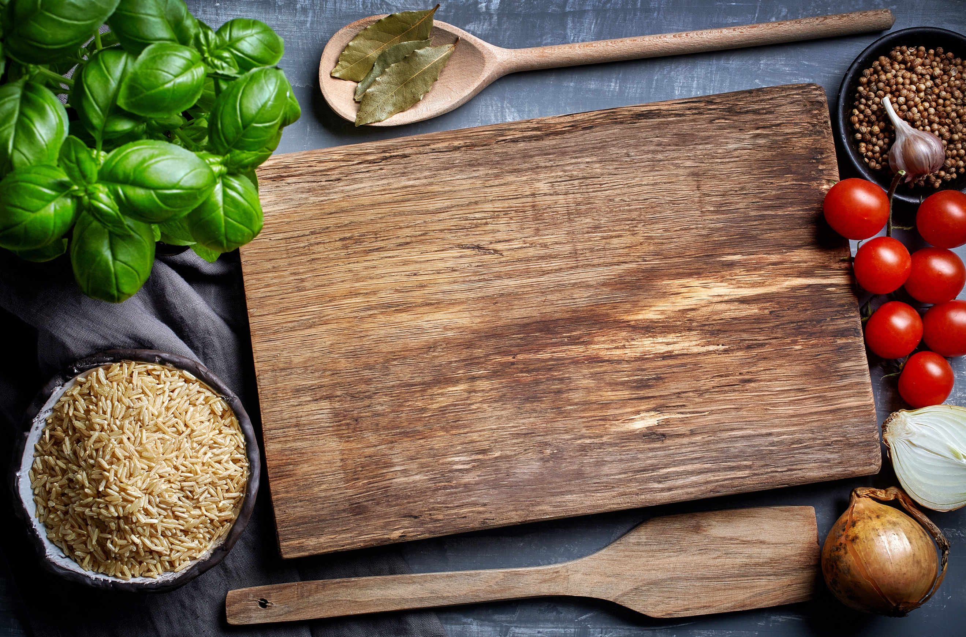

**Geranium**

Steam-extracted primarily from the leaves and stems of the geranium plant and an uplifting aroma Rose Geranium essential oil contains enzymes that help regulate the production of skin oils. This makes it versatile for all types of skin, particularly dry skin. However, its astringent abilities help to balance the production of sebum in the skin, making it an ideal essential oil to use on oily and dry skin as well.  Non-irritating so it’s an ideal essential oil to use on eczema and dermatitis. Geranium oil has anti-inflammatory properties indicated in this [study](https://www.ncbi.nlm.nih.gov/pmc/articles/PMC3793238/).

[Goat Milk Soap WELLNESS No.33 Anti-Aging Blend](https://www.boguemilksoap.com/product/handmade-goat-milk-soapwellness-anti-aging/)

[Organic Shampoo No.21 Chiefs Peak Blend](https://www.boguemilksoap.com/product/organic-shampoo-chiefs-peak-with-added-kukui-and-essential-oils/)

[Moisturizing Goat Milk Soap three bar Giftset](https://www.boguemilksoap.com/product/moisturizing-goat-milk-soap-3-bar-giftset-no-9-no-20-no-21/)

**Tea Tree**

Tea tree essential oil invigorating, fresh & clean aroma make it perfect for bath products. Long been recognized for its antibacterial, antifungal, and antiseptic qualities it is an effective [acne fighting agent](https://europepmc.org/abstract/med/2145499) with fewer toxic side effects than benzoyl peroxide. Tea tree essential oil also has the ability to fight off yeasts and fungi that can afflict the hair & body. Many of these qualities help it repel insects as well so great for cleaning up before or after an outdoor excursion.

[Goat Milk Soap BESPOKE No.28 Trailblazer Blend](https://www.boguemilksoap.com/product/bespoke-trailblazer-vetiver-tea-tree-citronella-give-insect-defense-sun-repelling-carrot-seed-join-fir-virginia-cedarwood-for-wildlife-camouflage/)

[BESPOKE Goat MIlk Soap three bar Giftset](https://www.boguemilksoap.com/product/goat-milk-soap-3-bar-giftset-bespoke-blends-for-a-healthy-life-no-18-no-19-no-28/)

**Eucalyptus**

The cooling vapors of eucalyptus oil has been a respiratory remedy for centuries, Eucalyptus essential oil has the [ability](https://link.springer.com/article/10.1007%2Fs00284-007-9045-0) to fight viruses and bacteria that cause fever, flu and sinus infections. Potent antimicrobial properties have secured eucalyptus essential oil a spot on the ingredient list for many medicinal products.

One of our most used oils [Studies](https://www.ncbi.nlm.nih.gov/pubmed/14611892) show eucalyptus oil is a potentially powerful analgesic and anti-inflammatory as well. Its invigorating aroma make it great for bring breathe awareness for a healthy body and mind.

[Essential Oil Roll-On No.19 Namaste Yoga blend](https://www.boguemilksoap.com/product/pure-essential-oil-roll-on-bogue-bespoke-no-19-namaste-yoga-blend-increase-breath-awareness-with-eucalyptus-holy-basil-ginger-vetiver-to-keep-you-centered/)

[Goat Milk Soap & Essential Oil Roll-On Giftset No.19 Yoga Blend](https://www.boguemilksoap.com/product/goat-milk-soap-pure-essential-oil-roll-on-giftsetbespoke-no-19-namaste-yoga-blend-increase-breath-awareness-with-eucalyptus-holy-basil-ginger-vetiver-to-keep-you-centered/)

[Goat Milk Body Lotion No.19 Namaste Yoga Blend](https://www.boguemilksoap.com/product/goat-milk-body-lotion-bespoke-no-19-yoga-blend-with-essential-oils/)



**Lemongrass**

Lemongrass is a tall grass native to India and parts of Asia, often used for culinary and medicinal purposes. Lemongrass essential oil has one of our favorite uplifting and sweet, citrusy scent possessing diverse therapeutic properties. By calming inflammation and [strengthening elastin](https://www.salvatorebattaglia.com.au/lemongrass/), it can assist in combating aging or sagging skin. Combined with its [astringent](https://books.google.co.in/books?id=RfoJsFHFSnMC&pg=PA231&dq=lemongrass+for+skin&hl=en&sa=X&ei=UA0aUZvTMY-HmQWH64D4CQ&ved=0CDwQ6AEwAQ#v=onepage&q=lemongrass%20for%20skin&f=false) properties Lemongrass is also known to have [antibacterial properties](https://www.sciencedirect.com/science/article/pii/S1995764510601290) which can fight against a number of common bacterial infections. In combination with its antifungal and antiseptic qualities, makes lemongrass a simple but powerful ingredient for health and Wellness products.

[Goat Milk Soap BESPOKE No.12 Chefs Blend](https://www.boguemilksoap.com/product/goat-milk-soap-chefs-blend-with-essential-oils/)

[Goat Milk Lotion No.12 Chefs Blend](https://www.boguemilksoap.com/product/goat-milk-body-lotion-bespoke-no-12-chef-blend-with-essential-oil-botanicals/)

**Clary Sage**

Used medicinally in Europe for centuries, Clary sage is an herb closely related to common garden sage. Its steam distilled essential oil [Research has shown](https://www.sciencedirect.com/science/article/pii/S0378874110002667))  has the potential to be a powerful antidepressant in addition to its [antifungal](https://pubs.acs.org/doi/abs/10.1021/jf020422n) and [anti-inflammatory](https://www.sciencedirect.com/science/article/pii/S0944711304701804) qualities. Clary Sages antiviral properties have been shown to have [anti-influenza effects](https://www.ncbi.nlm.nih.gov/pubmed/30584499), making it effective in protecting against seasonal flu viruses.  While its aroma can have a calming effect. [One study](https://www.ncbi.nlm.nih.gov/pubmed/23360656) showed it’s soothing properties with a consistent reduction in blood pressure. Furthermore it is a strong [antibacterial](https://www.ncbi.nlm.nih.gov/pmc/articles/PMC4360007/) making it perfect for soaps. In addition it goes very well with other earthy scents, uplifing but calming, like eucalyptus, cedarwood, chamomile & rosemary that we paired it with in the following:

[Pure essential oil roll-on Wellness No.34 Calm Down Blend](https://www.boguemilksoap.com/product/essential-oil-roll-on-goat-milk-soap-giftset-no-34-calm-down-blend/)

[Organic Shampoo Wellness No.34 Calm Down Blend](https://www.boguemilksoap.com/product/n-34-wellness-calm-down-blend-organic-shampoo-with-added-argan-kukui-oils-calming-lavender-frankincense-clary-sage-ylang-ylang-relieve-stress-anxiety/)

**Bergamot**

By blending Bergamot essential oil with black tea, you get Earl Grey. This calming and familiar scent is from a lesser-known member of the citrus family and has some amazing therapeutic benefits. Extracted from the rinds of the fruit and has been shown to possess analgesic, antiseptic, antidepressant and sedative characteristics.

Great for the body + hair, [another study](https://www.ncbi.nlm.nih.gov/pubmed/30847114) found that bergamot essential oil is responsible for increases in skin collagen content and the promotion of hair growth.

[Studies have shown](https://www.ncbi.nlm.nih.gov/pubmed/30919084) that bergamot like Palo Santo essential oil, amazingly, may possess strong chemo preventive abilities as its compounds promote apoptosis. Apoptosis is the body’s natural and vital process of dead cell turnover making bergamot a potential cancer-fighter.

[Goat Milk Soap No.30 Exfoliating Grapeseen Blend](https://www.boguemilksoap.com/product/n-30-exfoliating-bar/)

[Goat Milk Shaving Soap Kit No.16 Topa Topa Blend](https://www.boguemilksoap.com/product/goat-milk-shaving-soap-kit-topa-topa-blend-with-13-essential-oils-rhassoul-clay/)

**Ylang Ylang**

The medicinal properties of ylang ylang essential oil tree have long been known and used to treat a wide variety of ailments. Made from the bark & flowers of the ylang-ylang tree which is common in the islands of the Indian Ocean. There are many active components in this fragrant essential oil which make it a potent [antimicrobial, anti-inflammatory, antioxidant, and insect repellent](https://www.ncbi.nlm.nih.gov/pmc/articles/PMC4534619/#B11).

The calming floral scent of ylang-ylang has been shown to [lower blood pressure](https://www.ncbi.nlm.nih.gov/pubmed/24278868/) and has an overall [relaxing effect on the mind and body](https://www.ncbi.nlm.nih.gov/pubmed/16807875/).

Applied to the skin “trans dermally” Ylang Ylang is  a skin-preserver, it has been found that ylang-ylang oil [contains antioxidants](https://www.ncbi.nlm.nih.gov/pmc/articles/PMC4534619/#B11) that promote skin rejuvenation by repairing the proteins and lipids in the skin. Additionally, the antioxidants in the oil have free radical-scavenging capacities, in other words it’s anti-aging.

[Goat Milk Soap & Essential oil Roll-On giftset](https://www.boguemilksoap.com/product/goat-milk-soap-pure-essential-oil-roll-on-no-10-giftset-eucalyptus/)

[Essential oil Hydrolizer Spray No.10 Walk on Sunshine Blend](https://www.boguemilksoap.com/product/essential-oil-hydrolyzer-spray-no-10-walking-on-sunshine/)

**Clove**

Clove aromatic oil has been traditionally used in [Ayurvedic medicine](https://en.wikipedia.org/wiki/Clove) and in Traditional Chinese Medicine for its antibacterial and antioxidant capabilities. The essential oil comes from the flower buds of the evergreen clove tree and it’s [pain-relieving ability](https://www.ncbi.nlm.nih.gov/pubmed/17380552) have been noted for centuries. It has been [found](https://www.ncbi.nlm.nih.gov/pubmed/25832173) to be an effective regulator of blood pressure, giving it relaxing benefits, and has long been touted as an aphrodisiac with [modern studies](https://www.ncbi.nlm.nih.gov/pmc/articles/PMC534794/) are providing efficacy to that claim

It has been shown to have [potential antifungal properties](https://www.ncbi.nlm.nih.gov/pubmed/15720571), exhibiting a strong response against *Candida albicans* and it has been shown to fight bacteria commonly associated with acne, making it a useful addition to skincare products. Commonly used in anti-aging skin care products due to its high content of Eugenol, a compound with [antioxidant properties](https://www.ncbi.nlm.nih.gov/pubmed/25842910).

Clove promotes a healthy balanced skin. Shown in [studies](https://www.ncbi.nlm.nih.gov/pubmed/28407719)  to activate tissue remodeling in human dermal fibroblasts (cells found within the second skin layer) which are responsible for generating connective tissue, as a result Clove is supporting the skin while it’s recovering.

[Goat Milk Soap wellness No.32 Detox blend](https://www.boguemilksoap.com/product/wellness-detox-blend/)

**Patchouli**

The woody, earthy scent of patchouli essential oil may be one of the most familiar aromatic essential oils, however it is also a close relative and often blended with oils of lavender and sage or the uplifting eucalyptus. Furthermore being a versatile oil, [showing](https://cigrjournal.org/index.php/Ejounral/article/view/2289/1746)) stimulating effects at a higher levels or relaxing effects with lower.

Furthermore, functioning as an [antioxidant](https://www.ncbi.nlm.nih.gov/pubmed/30622869), patchouli essential oil is a [superb tissue regenerator](https://cigrjournal.org/index.php/Ejounral/article/view/2289/1746) making it great for skincare. As an [antibacterial](https://sphinxsai.com/sphinxsaivol_2no.1/pharmtech_vol_2no.1/PharmTech_Vol_2No.1PDF/PT=69%20%28438-442%29.pdf) for soap and its antiseptic properties can help alleviate acne. Lastly, Patchouli oil has [tonic properties](https://draxe.com/patchouli-oil/) that help to balance the skin.

[Goat Milk Soap Wellness No.36 Immunity Blend](https://www.boguemilksoap.com/product/goat-milk-soap-bar-wellness-no-36-immunity-blend-of-essential-oils/)

[Goat Milk Soap three bar Bespoke Giftset](https://www.boguemilksoap.com/product/goat-milk-soap-3-bar-giftset-bespoke-blends-for-a-healthy-life-no-18-no-19-no-28/)

**We use ONLY PURE ESSENTIAL OIL IN ALL OUR PRODUCTS**

For a healthy body and mind!

